Three Creative Ideas

Project Specifications
Fill out the project specifics that you get from the Project Specification Generator.

Product
Product Name: Permanent Markers
Product Brand (you get to choose this): Sharpie

Target Audience Demographics
Gender: Female
Age: 25-34
Relationship: Single
Education: High school
Income: $60,000-$89,000
Media Consumption: Magazines and Facebook

Ideas & Sketches
Provide a sketch and description of your three creative ideas. All three ideas should be based on the same product and target audience demographics listed above.

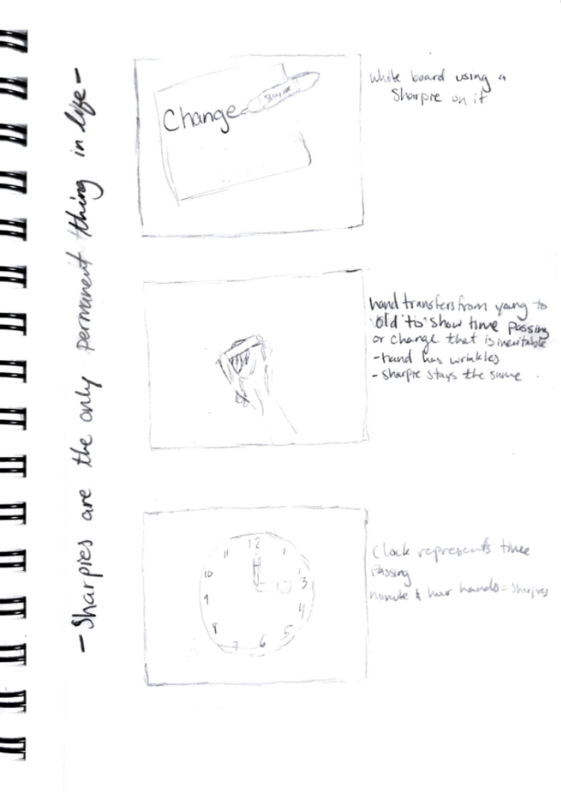
Idea #1
The first idea shown above is writing on the whiteboard with a sharpie the word change.

Idea #2
The second idea shown above is having a half aging hand and the other half younger looking, and the sharpie stays the same.

Idea #3
The last idea shown above is a clock which represents time passing, and the sharpies are the hands of the clock.

Add & Subtract Report

Explain what you decided to add and subtract from your daily routine this week.

I decided to add Journal writing and subtract screens in bed from my daily routine this week.

Progress
How many days did you complete these additions and subtractions from your daily routine? Explain your experience with these changes to your routine.

I added Journal writing for 5 days this week. I subtracted screens in bed from only 4 days this week. It was definitely easier to add something than subtract for me. The days that I remembered to do both it was amazing how much more productive I was.

Submission
Save this completed document as a PDF (File -> Save As - > File Format: PDF)
Submit the PDF in I-Learn

